Vanier College

Faculty of Science and Technology

System Development

420-436-VA

Feb. 14th, 2023

Deliverable 1

Green Team

Mert Kairstan Salvador

Maxym Galenko

Ali Raza

In collaboration with Marco Patulli

(Code from our eCommerce class will be used for certain features of this project)

We, the green team, certify that this assignment is our own work.

I, Mert Kairstan Salvador, student ID #2179970, certify that I have contributed to this deliverable, M.K.S.

I, Maxym Galenko, student ID #2060352, certify that I have contributed to this deliverable, M.G.

I, Ali Raza, student ID #2080455, certify that I have contributed to this deliverable, A.R.

# Executive Overview

_____________________________________________________________________________________

Our project is a prototype e-Commerce Project web application for a client. Our client is Marco who is a small personal computer business owner located in Montreal. He offers laptops, pc builds and commissions. To achieve this e-commerce web application prototype, our team has set weekly meetings during every Friday at 8:00 – 10:00. In these meetings, all team members will report their current progress as well as the current status of their work, any complications such as problems they have with their code, needing more time, and so on.

Our team will be using discord as our main communication method, and we will be using GitHub as our shared repository (The GitHub repository will be in Maxym’s account). As for project planning, we will be using Project Libre for detailing each task, estimating the time for each task, updating the tasks, start/end times, sequencing, assigned members, etc. work time, start/end dates, the sequencing, and their assigned members (see Project Plan).

As per the general project instructions, a new team leader will be assigned for each deliverable over the course of the semester. Each of the tasks will be assigned to the team member most suited for the necessary skills and capabilities, although changes can be made due to external factors such as sickness or doctor appointments. The responsibilities provided will be in rotation during each deliverable, some of them such as the minutes reports as well as client communications, will remain the responsibility of a singular member throughout the project to keep clean and consistent notes of our progress as well as to make our client comfortable with communications.

# Client/Sponsor

_____________________________________________________________________________________

Our client’s name is Marco Patulli, he is currently a college student, while also running a side pc building business on Instagram. There he posts multiple pc builds that he has done for clients, as well selling laptops (as seen below in the pictures). His products target people of all ages looking to get a pc perfect for their needs and are almost always custom built.

Our client does not have any knowledge in any programming languages but is proficient in computer components. He is a college student who is well informed in the use of modern technology and computers. He runs his small business mostly alone but is sometimes aided by his girlfriend. Therefore, only they will be the ones who will run the website we make for him.

Our client’s main business problem is inventory. He needs a website application that can handle inventory management, as well as a page where clients can select the pc parts themselves, listing pc builds/components, and customer shopping.

-------------------------------------------- Pictures -------------------------------------------

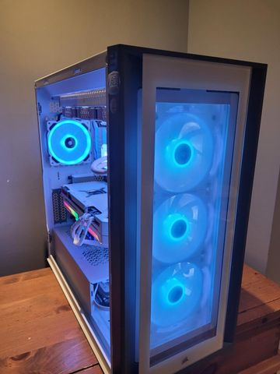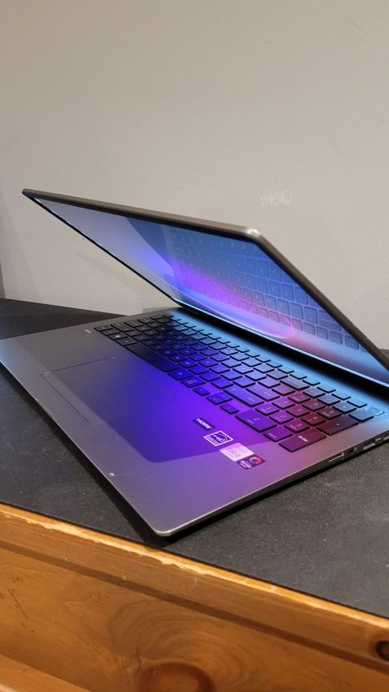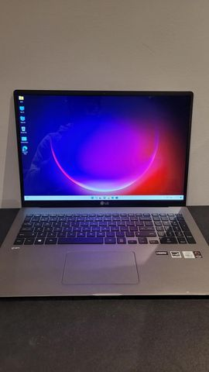

# Team Organization

_____________________________________________________________________________________

Meeting Schedules:

As a team we have agreed to meet at during these specific dates:

* Mondays at 10:00 a.m. – 12:00 p.m.

Located in school. During lectures. (Mandatory)

* Wednesdays at 1:30 p.m. – 4:30 p.m.

Located in school. During lab. (Mandatory)

* Thursdays at 4:00 p.m. to 6:00 p.m.

Located in school During lectures. (Mandatory)

* Fridays at 8:00 – 10:00

Located in Discord (Occasional status report and comments)

We use sublime for our minutes and some examples of it can be found below:

------------------------------------------ Picture -----------------------------------------------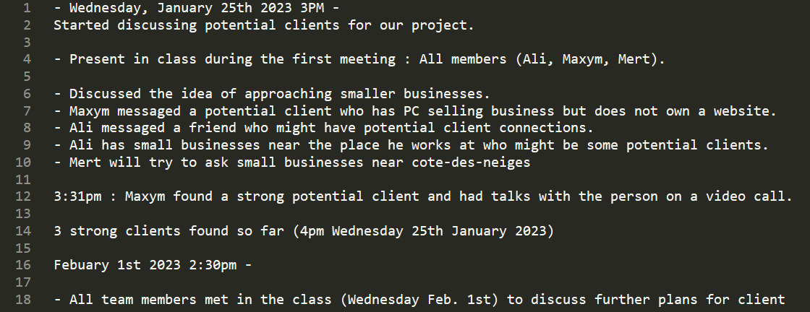

## Repositories:

Our team have decided to work GitHub for our repository and Discord for communications. We have GitHub because it provides a set of features ideal for version control.

We have also agreed to appropriately title each commit. In order to avoid any confusions in case anything goes wrong.

GitHub:

Master repository: <https://github.com/MaxGalenko/Websit-Project>

* Mert: GoMerKs
* Maxym: MaxGalenko
* Ali: Aliraza1002

## Communications:

Our team has decided to use Discord for communications, mainly because it is preferred and most used communication device in our arsenal. This is also what we have agreed on because we are familiar with a multitude of its features such as screen sharing.

We have also agreed that for the first 10 mins we report the current status of our work, followed by what we will be doing next. And leave debate at the end for any issues that arises. We have also agreed to do our best to follow the specified schedule as well as respect each other to avoid any conflicts. We have also agreed to try completing our responsibilities before the agreed upon deadline.

Discord:

* Mert: SomberRain
* Maxym: Gryphius
* Ali: Ali.

## Synchronous Meetings:

The synchronous meetings that include all team members is written above, located in the meeting schedules of this document. We will be meeting in person throughout the week except Fridays which we will be meeting online in Discord. In order to avoid making the time and effort to travel to school. Since we will, already mostly be in school.

## Areas of responsibility:

Most of the responsibilities will be in rotation among the team members. With a few remaining the same throughout the project.

* Maxym will be the main in contact with our client mainly because he and the client are familiar with each other, having the same acquaintance.
* Ali will continuously be writing our reports because he has written most of it, therefore we decided to let him continue writing the notes for consistency.

And the responsibilities we have decided to rotate are

* The team leader, the chairperson changes after every deliverable, which is chosen by the instructor.
* We have also decided the team leader become the secondary contact with our client. This makes sure that the client becomes comfortable communicating with all the team members with no bias and preference.

## Contact Information:

We as a team have a general consensus not to reveal any personal information due to privacy, therefore we have decided to only share our emails.

* Mert: pal.82172134@gmail.com
* Maxym: maxymgalenko@gmail.com
* Ali: aliraza_159@outlook.com

## Client Contact:

We have decided the main contact is Maxym for having already been familiar with the client. Therefore, he will be the vanguard, asking questions and getting additional information from the client. The secondary contact will be the notetaker and making progress reports to the client, asking whether this feature is to their liking or whether we should change something. Finally, our reason for having two contacts is to one, slowly make our client more comfortable using the main contact and two, gradually introduce the other team member to the client via the second contact.

* Email: mpatulli2004@gmail.com
* Instagram: @marco._.pat

## Reports:

We have decided as a group to:

* Have a short meeting every Friday.
* Having the team leader confirm everyone is doing their responsibilities.
* Having the team leader confirm everyone’s signature.

(To have everyone agree for fairness reasons)

* Having everyone review and look the deliverables to finalize it.
* Having everyone check for any missing content or mistakes.
* Having everyone do one final look before unanimously agreeing to submit it.

# Project Plan

This gantt chart is also provided with the deliverable.